Appendix 1

FIRST STAGE

DATE: RAT NUMBER:

#DAY OF THE EXPERIMENT
# DAY IN STAGE 1:
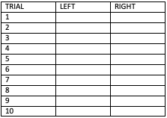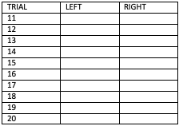
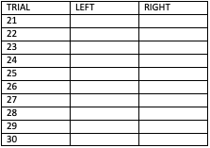

SECOND STAGE
DATE: RAT NUMBER:

#DAY OF THE EXPERIMENT:
# DAY IN STAGE 2:
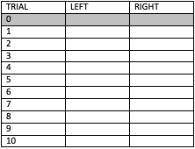
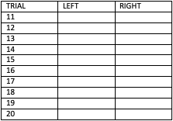
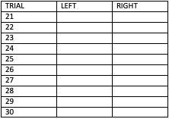

THIRD STAGE
DATE: RAT NUMBER:

#DAY OF THE EXPERIMENT:
# DAY IN STAGE 3:

Delay type: Delay type:

Delay type:

